FML Project - Krishna Kumar Tavva - 811283461

2023-05-07

*Setting default values to get a clean output*

knitr::opts_chunk$set(message = FALSE)  
knitr::opts_chunk$set(warning = FALSE)  
rm(list = ls())

*Loading the required packages*

library("readr")  
library("dplyr")  
library("ISLR")  
library("caret")  
library("class")  
library("ggplot2")  
library("FactoMineR")  
library("ggcorrplot")  
library("corrr")  
library("tidyverse")  
library("esquisse")  
library("gmodels")  
library("factoextra")  
library("fpc")  
library("cluster")  
library("pandoc")  
library("pander")

setwd("E:/MSBA Github Repository/64060_ktavva/Final Project")

*Loading the data*

Fuel_Receipts <- read.csv("Fuel_Receipts.csv")  
  
row.names(Fuel_Receipts) <- Fuel_Receipts[,1] #changing column name of Fuel data set to row name  
  
head(Fuel_Receipts)

## rowid plant_id_eia plant_id_eia_label report_date contract_type_code  
## 1 1 3 Barry 01-01-08 C  
## 2 2 3 Barry 01-01-08 C  
## 3 3 3 Barry 01-01-08 C  
## 4 4 7 Gadsden 01-01-08 C  
## 5 5 7 Gadsden 01-01-08 S  
## 6 6 7 Gadsden 01-01-08 S  
## contract_type_code_label contract_expiration_date energy_source_code  
## 1 C 01-04-08 BIT  
## 2 C 01-04-08 BIT  
## 3 C NG  
## 4 C 01-12-15 BIT  
## 5 S 01-11-08 BIT  
## 6 S 01-01-08 BIT  
## energy_source_code_label fuel_type_code_pudl fuel_group_code mine_id_pudl  
## 1 BIT coal coal 0  
## 2 BIT coal coal 0  
## 3 NG gas natural_gas NA  
## 4 BIT coal coal 1  
## 5 BIT coal coal 2  
## 6 BIT coal coal 3  
## mine_id_pudl_label supplier_name fuel_received_units fuel_mmbtu_per_unit  
## 1 0 interocean coal 259412 23.100  
## 2 0 interocean coal 52241 22.800  
## 3 NA bay gas pipeline 2783619 1.039  
## 4 1 alabama coal 25397 24.610  
## 5 2 d & e mining 764 24.446  
## 6 3 alabama coal 603 24.577  
## sulfur_content_pct ash_content_pct mercury_content_ppm fuel_cost_per_mmbtu  
## 1 0.49 5.4 NA 2.135  
## 2 0.48 5.7 NA 2.115  
## 3 0.00 0.0 NA 8.631  
## 4 1.69 14.7 NA 2.776  
## 5 0.84 15.5 NA 3.381  
## 6 1.54 14.6 NA 2.199  
## primary_transportation_mode_code primary_transportation_mode_code_label  
## 1 RV RV  
## 2 RV RV  
## 3 PL PL  
## 4 TR TR  
## 5 TR TR  
## 6 TR TR  
## secondary_transportation_mode_code secondary_transportation_mode_code_label  
## 1   
## 2   
## 3   
## 4   
## 5   
## 6   
## natural_gas_transport_code natural_gas_delivery_contract_type_code  
## 1 firm   
## 2 firm   
## 3 firm   
## 4 firm   
## 5 firm   
## 6 firm   
## moisture_content_pct chlorine_content_ppm data_maturity data_maturity_label  
## 1 NA NA final final  
## 2 NA NA final final  
## 3 NA NA final final  
## 4 NA NA final final  
## 5 NA NA final final  
## 6 NA NA final final

str(Fuel_Receipts)

## 'data.frame': 608564 obs. of 30 variables:  
## $ rowid : int 1 2 3 4 5 6 7 8 9 10 ...  
## $ plant_id_eia : int 3 3 3 7 7 7 7 8 8 8 ...  
## $ plant_id_eia_label : chr "Barry" "Barry" "Barry" "Gadsden" ...  
## $ report_date : chr "01-01-08" "01-01-08" "01-01-08" "01-01-08" ...  
## $ contract_type_code : chr "C" "C" "C" "C" ...  
## $ contract_type_code_label : chr "C" "C" "C" "C" ...  
## $ contract_expiration_date : chr "01-04-08" "01-04-08" "" "01-12-15" ...  
## $ energy_source_code : chr "BIT" "BIT" "NG" "BIT" ...  
## $ energy_source_code_label : chr "BIT" "BIT" "NG" "BIT" ...  
## $ fuel_type_code_pudl : chr "coal" "coal" "gas" "coal" ...  
## $ fuel_group_code : chr "coal" "coal" "natural_gas" "coal" ...  
## $ mine_id_pudl : int 0 0 NA 1 2 3 NA 4 4 1 ...  
## $ mine_id_pudl_label : int 0 0 NA 1 2 3 NA 4 4 1 ...  
## $ supplier_name : chr "interocean coal" "interocean coal" "bay gas pipeline" "alabama coal" ...  
## $ fuel_received_units : int 259412 52241 2783619 25397 764 603 2341 8869 75442 206741 ...  
## $ fuel_mmbtu_per_unit : num 23.1 22.8 1.04 24.61 24.45 ...  
## $ sulfur_content_pct : num 0.49 0.48 0 1.69 0.84 1.54 0 2.16 1.24 1.9 ...  
## $ ash_content_pct : num 5.4 5.7 0 14.7 15.5 14.6 0 15.4 11.9 15.4 ...  
## $ mercury_content_ppm : num NA NA NA NA NA NA NA NA NA NA ...  
## $ fuel_cost_per_mmbtu : num 2.13 2.12 8.63 2.78 3.38 ...  
## $ primary_transportation_mode_code : chr "RV" "RV" "PL" "TR" ...  
## $ primary_transportation_mode_code_label : chr "RV" "RV" "PL" "TR" ...  
## $ secondary_transportation_mode_code : chr "" "" "" "" ...  
## $ secondary_transportation_mode_code_label: chr "" "" "" "" ...  
## $ natural_gas_transport_code : chr "firm" "firm" "firm" "firm" ...  
## $ natural_gas_delivery_contract_type_code : chr "" "" "" "" ...  
## $ moisture_content_pct : num NA NA NA NA NA NA NA NA NA NA ...  
## $ chlorine_content_ppm : int NA NA NA NA NA NA NA NA NA NA ...  
## $ data_maturity : chr "final" "final" "final" "final" ...  
## $ data_maturity_label : chr "final" "final" "final" "final" ...

summary(Fuel_Receipts)

## rowid plant_id_eia plant_id_eia_label report_date   
## Min. : 1 Min. : 3 Length:608564 Length:608564   
## 1st Qu.:152142 1st Qu.: 2712 Class :character Class :character   
## Median :304283 Median : 6155 Mode :character Mode :character   
## Mean :304283 Mean :18290   
## 3rd Qu.:456423 3rd Qu.:50707   
## Max. :608564 Max. :64020   
##   
## contract_type_code contract_type_code_label contract_expiration_date  
## Length:608564 Length:608564 Length:608564   
## Class :character Class :character Class :character   
## Mode :character Mode :character Mode :character   
##   
##   
##   
##   
## energy_source_code energy_source_code_label fuel_type_code_pudl  
## Length:608564 Length:608564 Length:608564   
## Class :character Class :character Class :character   
## Mode :character Mode :character Mode :character   
##   
##   
##   
##   
## fuel_group_code mine_id_pudl mine_id_pudl_label supplier_name   
## Length:608564 Min. : 0 Min. : 0 Length:608564   
## Class :character 1st Qu.: 42 1st Qu.: 42 Class :character   
## Mode :character Median : 972 Median : 972 Mode :character   
## Mean :1577 Mean :1577   
## 3rd Qu.:3121 3rd Qu.:3121   
## Max. :4562 Max. :4562   
## NA's :391946 NA's :391946   
## fuel_received_units fuel_mmbtu_per_unit sulfur_content_pct ash_content_pct   
## Min. : 1 Min. : 0.000 Min. : 0.0000 Min. : 0.000   
## 1st Qu.: 3700 1st Qu.: 1.025 1st Qu.: 0.0000 1st Qu.: 0.000   
## Median : 21565 Median : 1.061 Median : 0.0000 Median : 0.000   
## Mean : 242967 Mean : 8.839 Mean : 0.5145 Mean : 3.606   
## 3rd Qu.: 106164 3rd Qu.: 17.809 3rd Qu.: 0.4900 3rd Qu.: 5.800   
## Max. :48159765 Max. :1049.000 Max. :11.0100 Max. :72.200   
##   
## mercury_content_ppm fuel_cost_per_mmbtu primary_transportation_mode_code  
## Min. :0.00 Min. : -71.9 Length:608564   
## 1st Qu.:0.00 1st Qu.: 2.3 Class :character   
## Median :0.00 Median : 3.3 Mode :character   
## Mean :0.01 Mean : 14.2   
## 3rd Qu.:0.00 3rd Qu.: 4.8   
## Max. :1.82 Max. :562572.2   
## NA's :289482 NA's :200240   
## primary_transportation_mode_code_label secondary_transportation_mode_code  
## Length:608564 Length:608564   
## Class :character Class :character   
## Mode :character Mode :character   
##   
##   
##   
##   
## secondary_transportation_mode_code_label natural_gas_transport_code  
## Length:608564 Length:608564   
## Class :character Class :character   
## Mode :character Mode :character   
##   
##   
##   
##   
## natural_gas_delivery_contract_type_code moisture_content_pct  
## Length:608564 Min. : 0.0   
## Class :character 1st Qu.: 6.6   
## Mode :character Median : 11.9   
## Mean : 15.6   
## 3rd Qu.: 26.8   
## Max. :247.0   
## NA's :516588   
## chlorine_content_ppm data_maturity data_maturity_label  
## Min. : 0.0 Length:608564 Length:608564   
## 1st Qu.: 0.0 Class :character Class :character   
## Median : 0.0 Mode :character Mode :character   
## Mean : 59.2   
## 3rd Qu.: 0.0   
## Max. :3747.0   
## NA's :516588

#Removing Unnecessary Variables  
Fuel_Data <- Fuel_Receipts[,-c(1,3:5,7,9,10,12:14,21:30)]

*Data Cleaning & Transformation*

#Looking for missing Values  
colMeans(is.na(Fuel_Data))

## plant_id_eia contract_type_code_label energy_source_code   
## 0.0000000 0.0000000 0.0000000   
## fuel_group_code fuel_received_units fuel_mmbtu_per_unit   
## 0.0000000 0.0000000 0.0000000   
## sulfur_content_pct ash_content_pct mercury_content_ppm   
## 0.0000000 0.0000000 0.4756805   
## fuel_cost_per_mmbtu   
## 0.3290369

#Treating the null values with median of the column.  
Fuel_Data$mercury_content_ppm[is.na(Fuel_Data$mercury_content_ppm)] <-  
 median(Fuel_Data$mercury_content_ppm, na.rm = T)  
  
Fuel_Data$fuel_cost_per_mmbtu[is.na(Fuel_Data$fuel_cost_per_mmbtu)] <-  
 median(Fuel_Data$fuel_cost_per_mmbtu, na.rm = T)

#Dropping all variables that have significant missing values  
any(is.na.data.frame(Fuel_Data)) #checking the data after omitting null values

## [1] FALSE

*Data Partition and Normalization*

#Data Partition  
set.seed(1234)  
Data_Part <- createDataPartition(Fuel_Data$fuel_cost_per_mmbtu,  
 p=0.02,list=F)  
Fuel_Data_part <- Fuel_Data[Data_Part,]  
Data_Part_Train <- createDataPartition(Fuel_Data_part$fuel_cost_per_mmbt,  
 p=0.75,list=F)  
  
Train_Data <- Fuel_Data_part[Data_Part_Train,]  
Test_Data <- Fuel_Data_part[-Data_Part_Train,]  
summary(Train_Data[,-c(1:4)])

## fuel_received_units fuel_mmbtu_per_unit sulfur_content_pct ash_content_pct   
## Min. : 1 Min. : 0.077 Min. :0.0000 Min. : 0.000   
## 1st Qu.: 3464 1st Qu.: 1.025 1st Qu.:0.0000 1st Qu.: 0.000   
## Median : 20758 Median : 1.060 Median :0.0000 Median : 0.000   
## Mean : 242805 Mean : 8.809 Mean :0.5223 Mean : 3.619   
## 3rd Qu.: 103600 3rd Qu.:17.810 3rd Qu.:0.5000 3rd Qu.: 6.000   
## Max. :12560185 Max. :29.570 Max. :7.8100 Max. :69.300   
## mercury_content_ppm fuel_cost_per_mmbtu  
## Min. :0.000000 Min. : 0.000   
## 1st Qu.:0.000000 1st Qu.: 2.747   
## Median :0.000000 Median : 3.276   
## Mean :0.004328 Mean : 7.803   
## 3rd Qu.:0.000000 3rd Qu.: 3.948   
## Max. :1.820000 Max. :11750.256

#Normalization  
Normalized_Data <- scale(Fuel_Data_part[,-c(1:4)])  
Normalized_Train <- scale(Train_Data[,-c(1:4)])  
summary(Normalized_Train)

## fuel_received_units fuel_mmbtu_per_unit sulfur_content_pct ash_content_pct   
## Min. :-0.3261 Min. :-0.8918 Min. :-0.51756 Min. :-0.5454   
## 1st Qu.:-0.3215 1st Qu.:-0.7950 1st Qu.:-0.51756 1st Qu.:-0.5454   
## Median :-0.2982 Median :-0.7914 Median :-0.51756 Median :-0.5454   
## Mean : 0.0000 Mean : 0.0000 Mean : 0.00000 Mean : 0.0000   
## 3rd Qu.:-0.1870 3rd Qu.: 0.9192 3rd Qu.:-0.02206 3rd Qu.: 0.3588   
## Max. :16.5434 Max. : 2.1203 Max. : 7.22206 Max. : 9.8981   
## mercury_content_ppm fuel_cost_per_mmbtu  
## Min. :-0.1168 Min. :-0.05216   
## 1st Qu.:-0.1168 1st Qu.:-0.03379   
## Median :-0.1168 Median :-0.03026   
## Mean : 0.0000 Mean : 0.00000   
## 3rd Qu.:-0.1168 3rd Qu.:-0.02577   
## Max. :49.0101 Max. :78.49493

Normalized_Test <- scale(Test_Data[,-c(1:4)])  
summary(Normalized_Test)

## fuel_received_units fuel_mmbtu_per_unit sulfur_content_pct ash_content_pct   
## Min. :-0.3155 Min. :-0.9054 Min. :-0.526923 Min. :-0.5663   
## 1st Qu.:-0.3109 1st Qu.:-0.8100 1st Qu.:-0.526923 1st Qu.:-0.5663   
## Median :-0.2881 Median :-0.8062 Median :-0.526923 Median :-0.5663   
## Mean : 0.0000 Mean : 0.0000 Mean : 0.000000 Mean : 0.0000   
## 3rd Qu.:-0.1705 3rd Qu.: 0.8975 3rd Qu.:-0.003089 3rd Qu.: 0.3913   
## Max. :18.9828 Max. : 2.0785 Max. : 6.523881 Max. : 8.9167   
## mercury_content_ppm fuel_cost_per_mmbtu  
## Min. :-0.1412 Min. :-0.21702   
## 1st Qu.:-0.1412 1st Qu.:-0.11468   
## Median :-0.1412 Median :-0.08895   
## Mean : 0.0000 Mean : 0.00000   
## 3rd Qu.:-0.1412 3rd Qu.:-0.05657   
## Max. :20.3333 Max. :45.56557

#Looking at the Correlation between Variables.  
corr_matrix <- cor(Normalized_Data)  
ggcorrplot(corr_matrix, outline.color = "grey50", lab = TRUE, hc.order = TRUE, type = "full")

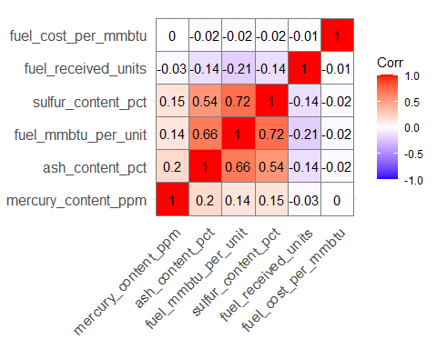

*Sulphur_content and ash_content_pct are highly positively correlated with Fuel_mmbtu_per_unit. There no much significant negatively correlated fields.*

data.pca <- princomp(corr_matrix)  
summary(data.pca)

## Importance of components:  
## Comp.1 Comp.2 Comp.3 Comp.4 Comp.5  
## Standard deviation 0.7772648 0.4083527 0.3768495 0.18664026 0.10215463  
## Proportion of Variance 0.6305096 0.1740302 0.1482141 0.03635501 0.01089105  
## Cumulative Proportion 0.6305096 0.8045398 0.9527539 0.98910895 1.00000000  
## Comp.6  
## Standard deviation 8.791168e-09  
## Proportion of Variance 8.065789e-17  
## Cumulative Proportion 1.000000e+00

*Six principal components have been generated (Comp.1 to Comp.6), which also correspond to the number of variables in the data. Each component explains a percentage of the total variance in the data set. In the Cumulative Proportion section, the first principal component explains almost 63% of the total variance. This implies that almost two-thirds of the data in the set of 6 variables can be represented by just the first principal component. The second one explains 17.4% of the total variance and the third one explains 14.8% of the total variance. The cumulative proportion of Comp.1, Comp.2 and Comp.3 explains nearly 95% of the total variance. This means that the first three principal components can accurately represent the data.*

data.pca$loadings[, 1:3]

## Comp.1 Comp.2 Comp.3  
## fuel_received_units 0.4268177 0.48805140 0.42234746  
## fuel_mmbtu_per_unit -0.5476821 -0.02528103 0.16857375  
## sulfur_content_pct -0.4927337 0.01228943 0.18978069  
## ash_content_pct -0.4731486 0.04137523 0.06844589  
## mercury_content_ppm -0.0548836 0.28057131 -0.86636862  
## fuel_cost_per_mmbtu 0.2195511 -0.82497485 -0.04369632

fviz_eig(data.pca, addlabels = TRUE)

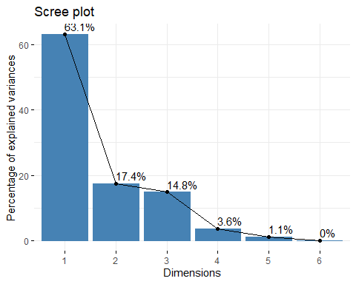

# Graph of the variables  
fviz_pca_var(data.pca, col.var = "black")

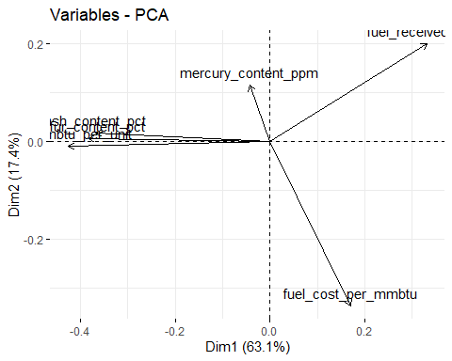 *All the variables that are grouped together are positively correlated to each other. The higher the distance between the variable and the origin, the better represented that variable is. The variables that are negatively correlated are displayed to the opposite sides of the biplot’s origin.*

*Finding the Optimal K*

#Elbow Method  
Elbow_method <- fviz_nbclust(Normalized_Train,kmeans,method="wss")  
Elbow_method

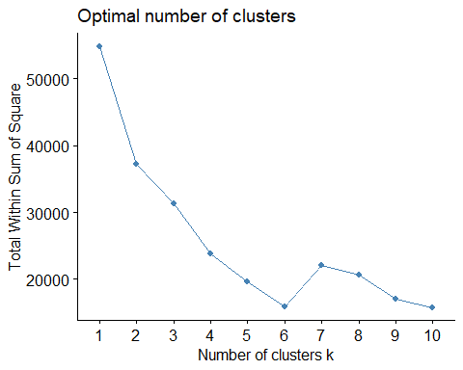

#Silhouette Method  
Silhouette <- fviz_nbclust(Normalized_Train,kmeans,method="silhouette")  
Silhouette

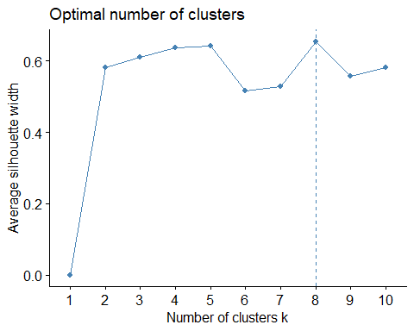 *The optimal value of k can be considered as k = 8 by using “Silhouette Method” as it is clear compared to Elbow Method.*

*Formulation of clusters with K=8*

#Using K Means -Silhouette  
kmeans_clust <- kmeans(Normalized_Train,centers = 8,nstart=25)  
pandoc.table(kmeans_clust$centers,style="grid", split.tables = Inf)

##   
##   
## +---------------------+---------------------+--------------------+-----------------+---------------------+---------------------+  
## | fuel_received_units | fuel_mmbtu_per_unit | sulfur_content_pct | ash_content_pct | mercury_content_ppm | fuel_cost_per_mmbtu |  
## +=====================+=====================+====================+=================+=====================+=====================+  
## | -0.3177 | -0.3088 | -0.3273 | -0.5447 | -0.1168 | 0.08907 |  
## +---------------------+---------------------+--------------------+-----------------+---------------------+---------------------+  
## | -0.1453 | -0.7948 | -0.5176 | -0.5454 | -0.1168 | -0.02138 |  
## +---------------------+---------------------+--------------------+-----------------+---------------------+---------------------+  
## | 2.58 | -0.7946 | -0.5176 | -0.5454 | -0.1168 | -0.02804 |  
## +---------------------+---------------------+--------------------+-----------------+---------------------+---------------------+  
## | -0.2462 | 1.185 | 0.07025 | 0.6753 | 0.1048 | -0.03446 |  
## +---------------------+---------------------+--------------------+-----------------+---------------------+---------------------+  
## | -0.326 | -0.7942 | -0.5176 | -0.5454 | -0.1168 | 49.88 |  
## +---------------------+---------------------+--------------------+-----------------+---------------------+---------------------+  
## | -0.2965 | 1.202 | 1.93 | 2.807 | 12.6 | -0.03051 |  
## +---------------------+---------------------+--------------------+-----------------+---------------------+---------------------+  
## | 7.955 | -0.8008 | -0.5176 | -0.5454 | -0.1168 | -0.0264 |  
## +---------------------+---------------------+--------------------+-----------------+---------------------+---------------------+  
## | -0.2772 | 1.43 | 2.281 | 1.418 | 0.03484 | -0.03386 |  
## +---------------------+---------------------+--------------------+-----------------+---------------------+---------------------+

kmeans_clust$size

## [1] 830 4430 486 2130 3 33 64 1156

*By employing the Silhouette Method we get 5 clusters of size 89,3,665,2916,6952,159,1340 and 50. Out of all, Cluster 4 has more number of observations.* *Whereas, “silhouette” as a method of finding optimal k gives the analyst/user a wider scope to understand the problem.* ***Thus, we say that by proceeding with k=8 we can ideally have a wider vision to look and also understand about the power generation in the US..***

cluster <- kmeans_clust$cluster  
kmean_clustering <- cbind(Train_Data, cluster)  
  
plot.cluster <- fviz_cluster(kmeans_clust, kmean_clustering[,-c(1:4)])  
plot.cluster

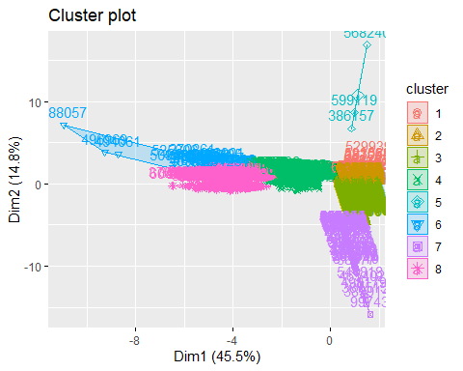

fuel_median <- kmean_clustering %>% group_by(cluster) %>%  
summarise(median_cost = median(fuel_cost_per_mmbtu),  
median_mmbtu = median(fuel_mmbtu_per_unit),  
median_received_units = median(fuel_received_units),  
median_sulfur = median(sulfur_content_pct)*0.01,  
median_ash = median(ash_content_pct)*0.1,  
median_mercury = median(mercury_content_ppm)*0.001)  
fuel_median

## # A tibble: 8 × 7  
## cluster median_cost median_mmbtu median_received_units median_sulfur  
## <int> <dbl> <dbl> <dbl> <dbl>  
## 1 1 11.6 5.8 828 0   
## 2 2 3.28 1.03 22154. 0   
## 3 3 3.28 1.03 2069810 0   
## 4 4 2.64 18.0 25185 0.0044  
## 5 5 6010. 1.04 27 0   
## 6 6 3.28 22.2 9532 0.0245  
## 7 7 3.28 1.03 5364812 0   
## 8 8 2.92 23.4 18815 0.0283  
## # ℹ 2 more variables: median_ash <dbl>, median_mercury <dbl>

fuel_clustering <- kmean_clustering %>% select(fuel_group_code, cluster) %>%   
group_by(fuel_group_code, cluster) %>% count() %>% arrange(cluster)  
fuel_clustering

## # A tibble: 13 × 3  
## # Groups: fuel_group_code, cluster [13]  
## fuel_group_code cluster n  
## <chr> <int> <int>  
## 1 coal 1 2  
## 2 natural_gas 1 11  
## 3 petroleum 1 817  
## 4 natural_gas 2 4403  
## 5 other_gas 2 27  
## 6 natural_gas 3 486  
## 7 coal 4 2130  
## 8 natural_gas 5 3  
## 9 coal 6 33  
## 10 natural_gas 7 60  
## 11 other_gas 7 4  
## 12 coal 8 1117  
## 13 petroleum_coke 8 39

Fuel_Plot <- ggplot(kmean_clustering) +  
 aes(x = cluster, fill = fuel_group_code) +  
 geom_histogram(bins = 30L) +  
 scale_fill_hue(direction = 1) +  
 labs(  
 x = "Clusters",  
 y = "Count",  
 title = "Fuel Types Used In Each Of The Cluster",  
 fill = "Fuel Type"  
) +  
 theme_minimal() +  
 theme(  
 plot.title = element_text(size = 14L,  
 face = "bold.italic",  
 hjust = 0.5),  
 axis.title.y = element_text(face = "bold"),  
 axis.title.x = element_text(face = "bold")  
)  
  
   
Fuel_Plot

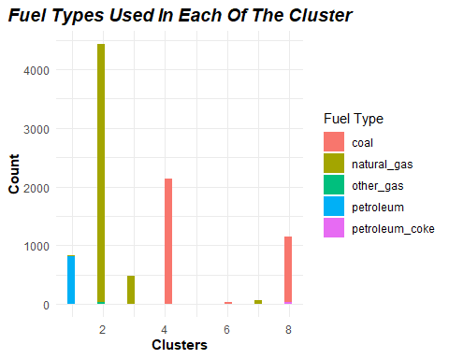

Heat_Content_Plot <- ggplot(kmean_clustering) +  
 aes(x = cluster, y = fuel_mmbtu_per_unit) +  
 geom_jitter(size = 1.5) +   
 labs(x = "Clusters",  
 y = "Heat Content",  
 title = "Heat Content Generated in Each Clusters",  
 subtitle = "In Metric Million British Thermal Units (MMBtu)") +  
 theme_minimal() +  
 theme(plot.title = element_text(size = 14L,  
 face = "bold.italic",  
 hjust = 0.5),  
 plot.subtitle = element_text(size = 10L,  
 face = "italic",  
 hjust = 0.5),  
 axis.title.y = element_text(size = 10L,  
 face = "bold"),  
 axis.title.x = element_text(size = 10L,  
 face = "bold"))  
Heat_Content_Plot

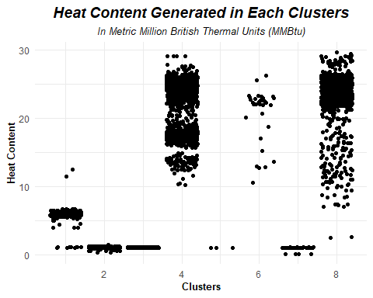

*Describing the cluster*

*Cluster 1: This cluster predominantly utilizes petroleum and natural gas as fuel sources for power generation. The median cost for generating power units with a heat content of 5.8 million metric British thermal units (MMBtu) is $11.6. This cluster generates a total of 828 units, and no impurities of Sulphur, mercury, or ash content are detected.*

*Cluster 2: Natural gas and other gases are the primary fuel sources in this cluster. The median cost for generating power units with a heat content of 1.0270 MMBtu is $3.276. This cluster generates approximately 22,154.5 units of power, and there are no impurities of Sulphur, mercury, or ash content.*

*Cluster 3: This cluster also relies on natural gas as its fuel source. The median cost for 1.0300 natural gas units is $3.276. It generates a significant amount of power with 2,069,810.0 units, which is the second highest among all clusters. No impurities are observed in this cluster.*

*Cluster 4: The fuel source in this cluster is coal. The price for generating power units with a heat content of 18.0220 MMBtu is $2.643. This cluster generates a total of 25,185.0 units of power. However, it exhibits impurities of ash exceeding the permissible levels at 0.65 parts per million (ppm) and Sulphur at 0.0044 ppm.*

*Cluster 5: Natural gas is once again the fuel source in this cluster. The median cost for generating power units, which includes extreme outliers, is $6010.289 for a heat content of 1.0370. This cluster generates a minimal amount of power, with only 27.0 units, and no impurities are present.*

*Cluster 6: Coal serves as the fuel source in this cluster. The price for generating power units with a heat content of 22.2140 MMBtu is $3.276. This cluster generates a total of 9,532.0 units of power. However, it surpasses the permissible levels of ash impurities at 2.02 ppm and Sulphur at 0.0245 ppm. Additionally, there is a presence of mercury impurities at 0.00038.*

*Cluster 7: Among all the clusters, this cluster generates the highest number of gas units for power generation, amounting to 5,364,812.0 units. The fuel sources used are natural gas and other gases. The price for generating power units with a heat content of 1.0255 MMBtu is $3.276. No impurities are detected in this cluster.*

*Cluster 8: This cluster utilizes coal and petroleum coke as fuel sources. The price for generating power units with a heat content of 23.3515 MMBtu is $2.916. It generates a total of 18,815.0 units of power. However, the cluster exhibits impurities of ash surpassing the permissible levels at 0.91 ppm, and Sulphur levels exceeding the permissible limit at 0.0283 ppm.*

#Extra Credit - building the model  
  
model<-lm(Fuel_Data_part$fuel_cost_per_mmbtu~.,data=Fuel_Data_part[,-c(2:4)])  
  
summary(model)

##   
## Call:  
## lm(formula = Fuel_Data_part$fuel_cost_per_mmbtu ~ ., data = Fuel_Data_part[,   
## -c(2:4)])  
##   
## Residuals:  
## Min 1Q Median 3Q Max   
## -11.8 -6.3 -3.0 0.0 11737.4   
##   
## Coefficients:  
## Estimate Std. Error t value Pr(>|t|)   
## (Intercept) 9.366e+00 2.200e+00 4.257 2.09e-05 ***  
## plant_id_eia 6.588e-05 5.704e-05 1.155 0.2481   
## fuel_received_units -2.789e-06 1.627e-06 -1.715 0.0865 .   
## fuel_mmbtu_per_unit -2.793e-01 2.056e-01 -1.359 0.1743   
## sulfur_content_pct 2.687e-01 1.724e+00 0.156 0.8762   
## ash_content_pct -1.108e-01 2.434e-01 -0.455 0.6490   
## mercury_content_ppm -8.738e-01 3.346e+01 -0.026 0.9792   
## ---  
## Signif. codes: 0 '***' 0.001 '**' 0.01 '*' 0.05 '.' 0.1 ' ' 1  
##   
## Residual standard error: 129.9 on 12167 degrees of freedom  
## Multiple R-squared: 0.0009032, Adjusted R-squared: 0.0004106   
## F-statistic: 1.833 on 6 and 12167 DF, p-value: 0.08848

*This shows that by choosing variables with significant relationship and cluster information leads to better prediction. Here we can see that our p value is greater than 5 % and r squared value is too low. This means variables we considered doesn’t account to the variability for fuel cost per mmbtu variable.*

#Finding variable importance   
  
varImp(model)

## Overall  
## plant_id_eia 1.1549331  
## fuel_received_units 1.7145515  
## fuel_mmbtu_per_unit 1.3586670  
## sulfur_content_pct 0.1557953  
## ash_content_pct 0.4551717  
## mercury_content_ppm 0.0261177

#Running the multiple linear regression model using just two variables which have greater statistical significance when compared to other variables  
model_1 <- lm(fuel_cost_per_mmbtu~fuel_mmbtu_per_unit+fuel_received_units,data=Train_Data[,-c(2:4)])  
summary(model_1)

##   
## Call:  
## lm(formula = fuel_cost_per_mmbtu ~ fuel_mmbtu_per_unit + fuel_received_units,   
## data = Train_Data[, -c(2:4)])  
##   
## Residuals:  
## Min 1Q Median 3Q Max   
## -11.7 -7.8 -4.0 0.1 11738.5   
##   
## Coefficients:  
## Estimate Std. Error t value Pr(>|t|)   
## (Intercept) 1.224e+01 2.263e+00 5.410 6.47e-08 ***  
## fuel_mmbtu_per_unit -4.210e-01 1.636e-01 -2.573 0.0101 *   
## fuel_received_units -3.002e-06 2.151e-06 -1.396 0.1629   
## ---  
## Signif. codes: 0 '***' 0.001 '**' 0.01 '*' 0.05 '.' 0.1 ' ' 1  
##   
## Residual standard error: 149.6 on 9129 degrees of freedom  
## Multiple R-squared: 0.0008073, Adjusted R-squared: 0.0005884   
## F-statistic: 3.688 on 2 and 9129 DF, p-value: 0.02507

*This shows that by choosing variables with significant relationship and cluster information leads to better prediction. Here we can see that our p value is greater than 1 % and r squared value is too low. This means variables we considered doesn’t account to the variability for fuel cost per mmbtu variable.*

model_predict <-predict(model_1,Test_Data,type="response")  
  
summary(model_predict)

## Min. 1st Qu. Median Mean 3rd Qu. Max.   
## -32.321 3.849 9.787 7.723 11.717 12.022

Test_Predict <- cbind(Test_Data,model_predict)

#The predicted value seems far away from the actual values, this can be referred by looking at the “Test_Predict” data frame.